**Master's/Bachelor's Program Management System**

**Project Proposal**

**CSE482L**

**Course Instructor: Md. Naqib Imtiaz Hussain (NQH)**

**Lab Instructor: Farjana Alam**

**Section: 01**

**Group: 08**

**Submitted By**

| **Name** | **ID** | **Email Address** |
| --- | --- | --- |
| **Ahmed Omar Salim Adnan** | **1831245042** | [**ahmed.adnan01@northsouth.edu**](mailto:ahmed.adnan01@northsouth.edu) |
| **Hosnara Happy** | **1813205042** | [**hosnara.happy@northsouth.edu**](mailto:hosnara.happy@northsouth.edu) |
| **Tammam Haque** | **1821151642** | [**tammam.haque@northsouth.edu**](mailto:tammam.haque@northsouth.edu) |

FEBRUARY 22, 2022

**Abstract**

This project's purpose is to create an online platform for students to go through different programs of different universities.The system's actual data is kept in an MYSQL database. Users will be able to search for different universities , search for different programs of those universities and learn more about them. They can have a look at the brief description of the programs . They can get in touch with the admin and provide feedback. They can also compare programs of different universities. They'll have individual profiles.

**Introduction**

This project's primary goal is to employ information technology to assist students enroll in their preferred program. As there are a ton of universities in our country now, students face a problem while making decisions regarding admission into universities. Sometimes they couldn’t find a proper description or idea about their desired university & programs.Our project will help them save both time and money. Each student has their preferences and learning objectives. Through our project they will be able to know better about their desired university & programs in it and also will be able to make a proper decision.

**Project overview**

An Master's/Bachelor's Program Management System contains data of different programs that are offered in different universities. It contains the name of different programs , courses offered in that program, a brief description of those courses etc. Users can get information about it and decide whether it catches their interest. Users can Also compare different programs and post their reviews. The admin maintains a database of the programs of different universities & also maintains the users.

**Project description**

The project is about creating a Master's/Bachelor's Program Management System. There are two panels of this management system.

* User panel.
* Admin panel.

USER PANEL:

The user will see an icon to get started. The user will be redirected to the registration form or signup by clicking on it. After signing up, the user will be redirected to the login page. Then the start icon will be changed into the My profile icon, and the login tab will change into the log-out icon. Users can find different university lists on the website homepage.They can find detailed information regarding those universities' various programs. They can also search for specific universities or programs in it. They can post their reviews and can also rate different courses of different programs. They can also view the feedback of different users regarding those programs. They can view the information about the website. They can contact the admin through a live chat/chat bot system. They can view the details of the courses of different programs . They can choose two or more courses or programs and can compare them according to the course hour, money to be paid for those, topics covered in those programs etc.They can also see a homepage of individual universities and can have a detailed contact of those universities & they can also find the location of the universities.They can edit and update their profile. They can reset their password. They can give feedback from their profile; They can log out.

ADMIN PANEL:

This panel can log in and see the total number of universities, programs, courses included in those programs and an unlimited number of users that are registered in the dashboard. The admin can change the password, see users’ feedback, and delete it. The admin can check the users details and can control it. The admin can view the details of the full website data and can add, edit and delete methods. The admin can add different universities details, programs details and course details including the brief description of those. Admin can edit or delete universities & programs as well.The admin can also monitor & control the website database.

**Background and project content**

**PROJECT:** Master's/Bachelor's Program Management System

**SIGNUP:**

*Register as a new user/admin

*The user needs a name, email, password to register.

* User must fill in other information

**SIGN IN:**

Whenever a user/admin signs in with an email and password, they will be redirected to the corresponding account home page.

**There are two panels of the management system.**

* User panel
* Admin panel.

**User panel**

**Homepage:**

It contains the get started icon signup option for registration, login option, description of all universities & programs that are available in the website. Contact us section, about us, category.

**My profile:**

Users can change their password, edit their profile, picture, name, give feedback, and log out.

**Programs:**

It contains the description of the courses that are present in each individual program.

**Search:**

Users can search for their desired university or programs by typing the name in the search bar.

**Review & Rating:**

Users can post their reviews for individual programs in the review section and can also rate the program with starts according to their experience.

**Admin panel**

**Admin Dashboard:**

Admin can view the total number universities & programs that are available on the website. Admin can also add different universities & different courses according to the need of the website. Admin can also see the total number of users registered in the website and can control them.

**Change Password:**

Admin can change the password by giving an email id and new password.

**Review & Rating:**

Admin can check feedback and also can delete it.

**User:**

Admin can view the user's name & email. Admin can also add, delete, edit users.

**User story**

| **As a []** | **I want to** | **So that** |
| --- | --- | --- |
| **As an user** | **Sign up** | **I can register to the system** |

| **As a registered user** | **Log in** | **I will have access to further features and log out of the**  **system any time** |
| --- | --- | --- |
| **As a normal user (both registered and visitors)** | **View programs of universities** | **I can search for the programs and compare** |
| **As a normal user (both registered and visitors)** | **View program Description, estimated total cost, ratings, reviews by clicking on the courses** | **I can have an idea**  **about the program I will be enrolled in the future, and compare programs to search for the best one that suits me** |
| **As a registered user** | **Update my profile information** | **I can edit my profile, change my profile picture and change my password** |
| **As a normal user (both**  **registered and visitors)** | **View chatbox** | **I can chat with the admins for queries** |
| **As a registered user** | **Give feedback** | **I can share my opinion**  **related to my experience on the system** |
| **As an admin** | **Login** | **I can maintain the**  **System and logout** |
| **As an admin** | **Have a dashboard** | **I can view the details of the programs** |
| **As an admin** | **Add and remove programs** | **I can update the contents** |
| **As an admin** | **View feedback** | **I can improve the system** |

Use Case 1:

**Title:** Registration to the system

**Actor:** User

**Description:**

· Input Username, password, confirm password.

· Store into database

**Exception:**

· page not available

· No database connection

**Precondition:**

1. URL of “Sign up” hyperlink page

**Post condition:**

· Successful: Registered successfully

· Unsuccessful: Registration incomplete/Incorrect details

Use Case 2:

**Title:** Login to the system

**Actor:** Registered User

**Description:**

· Input Username, password.

· Check password matches or not

**Exception:**

· page not available

· No database connection

**Precondition:**

1. URL of “Log in” hyperlink page

**Post condition:**

· Successful: Logged in successfully

· Unsuccessful: Login incomplete/Incorrect username/password.

Use Case 3:

**Title:** Homepage

**Actor:**  User

**Description:**

· About the website and its use

· User can select register/ login options

· User can search options

**Exception:**

· page not available

· No database connection

**Precondition:**

1. URL of “Homepage” hyperlink page

**Post condition:**

· Display searched details

· Direct to the register/ login page

Use Case 4:

**Title:**  Admin Dashboard

**Actor:**  Admin

**Description:**

· Admin can post

· Add/Delete Programs

· Maintain and Restrict Members

**Exception:**

· Page not available

· No database connection

**Precondition:**

1. URL of “Admin Dashboard” hyperlink page

**Post condition:**

· Display Dashboard Icons

Use Case 5:

**Title:** University Page

**Actor:** Registered User

**Description:**

· Check University description

· Map API Location for universities

**Exception:**

· page not available

· No database connection

**Precondition:**

1. URL of “University Page” hyperlink page

**Post condition:**

· Display all university description

· Display location on the map

Use Case 6:

**Title:** Program Page

**Actor:** Registered User

**Description:**

· Check Program details

· User can estimate total cost

· User can also rate and add comments

**Exception:**

· page not available

· No database connection

**Precondition:**

1. URL of “Program Page” hyperlink page

**Post condition:**

· Display program details and calculated cost

Use Case 7:

**Title:** Course Compare

**Actor:** Registered User

**Description:**

· Check Course details

· Compare details by ratings

**Exception:**

· page not available

· No database connection

**Precondition:**

1. URL of “Course Compare” hyperlink page

**Post condition:**

· Display compared results

· Display from highest rated to lowest rated

Use Case 8:

**Title:** Chat Bot/Live Chat

**Actor:** Registered User/Admin

**Description:**

· Live chat with Admin

· Any query can be asked in real time

**Exception:**

· page not available

· No database connection

**Precondition:**

1. URL of “Chat Bot” hyperlink page

**Post condition:**

· Display conversation on message box

**Use Case Diagram:**

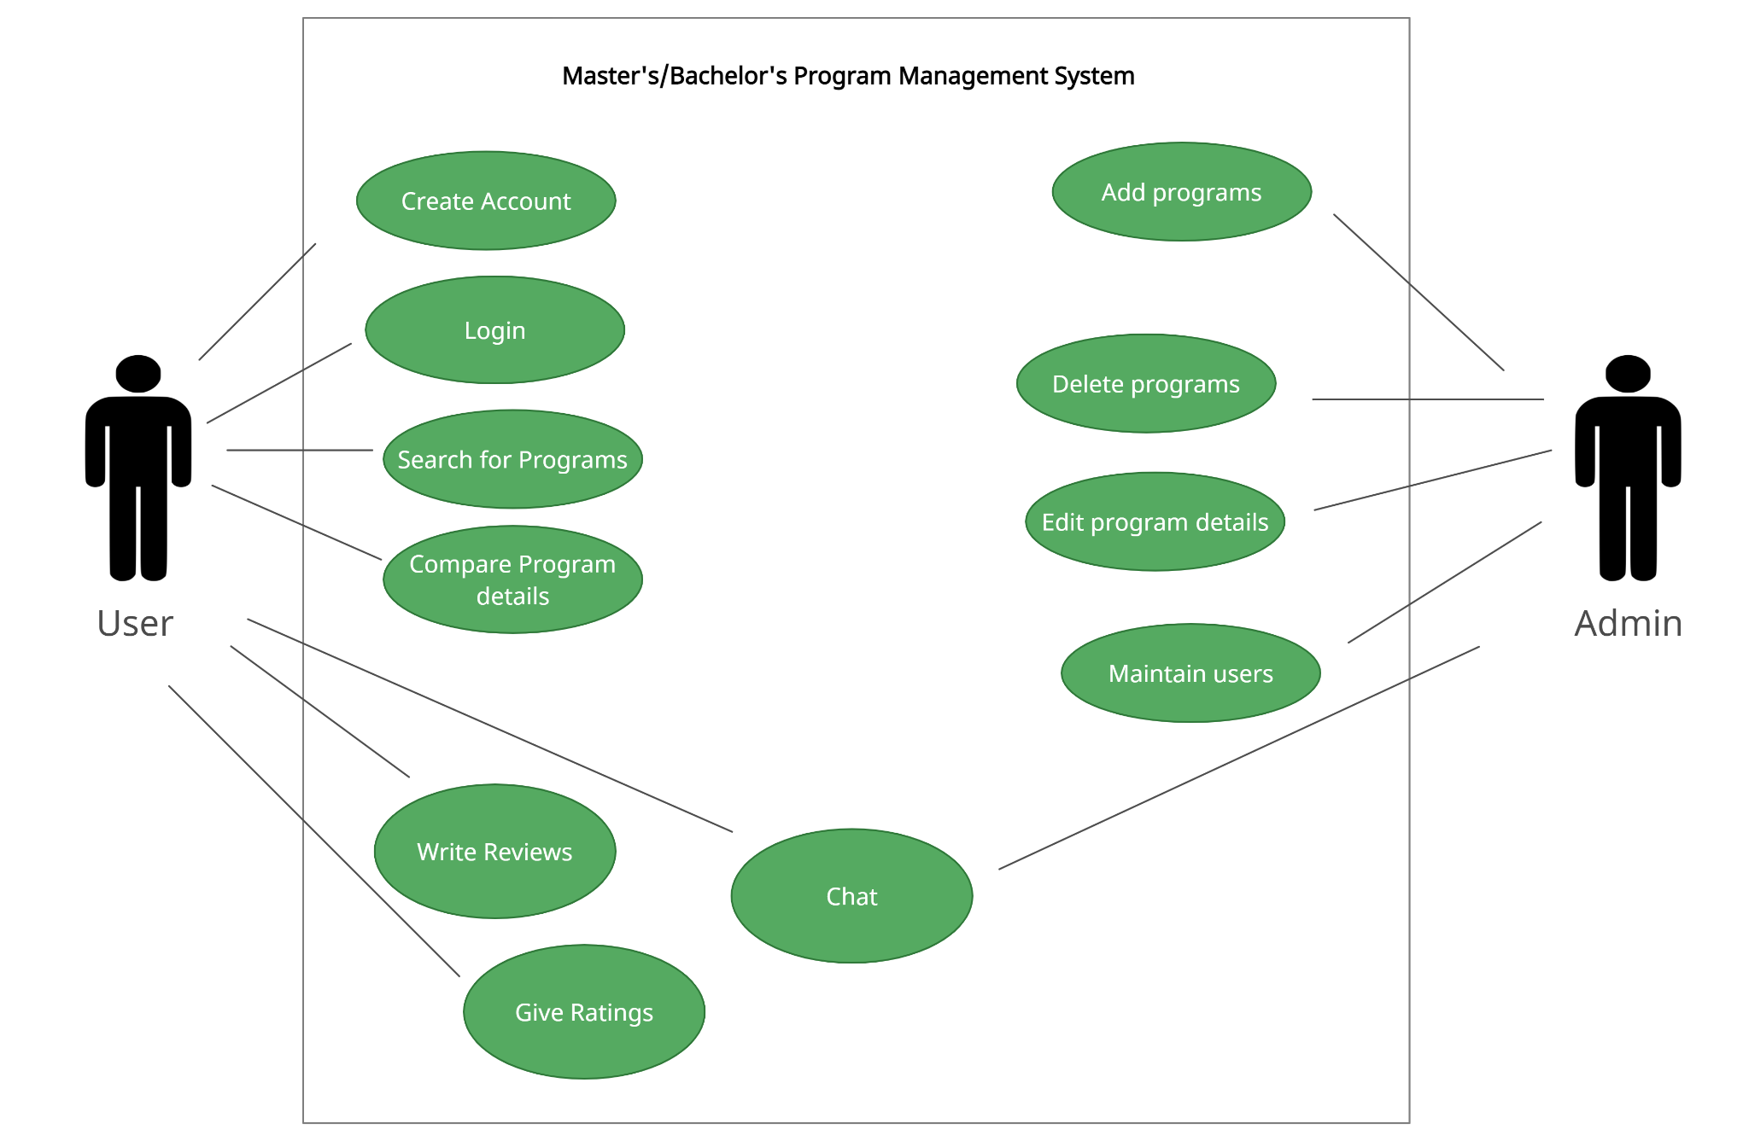

**Software and tools**

We will use Html, CSS, and Bootstrap for frontend design, and JavaScript to make our website functional.



For the backend we will use MySQL database and connect it to the frontend with PHP.



**Front-end plan**

There are two-panels in the front-end part. One is a user, and one is an admin.

* Signup page for user
* The login page for the user
* The login page for the admin
* Homepage for user
* Profile page for user
* Program pages
* Feedback page for user
* Change password page for users
* Dashboard for admin
* Feedback page for admin
* Maintaining users page for admin
* Maintaining programs page for admin

**Back-end plan**

* **Account creating:**
* Sign-up
* Log-in
* MYSQL Database
* **Profile Management:**
* User profile
* Admin Profile
* **Searching facility:**
* Searching university Id
* Searching program Id

**Development plan**

**The first week**

This week was the first week where we planned the structure of our website. Decided which feature to be included and worked on the project proposal.

**The second week**

In the second week, we will divide work among ourselves. We will focus on creating and functioning our authorization part (registration and login), and create the front-end template of the homepage and admin page.

**The third week**

We will aim to create the front-end templates of the remaining pages by the third week.

**The fourth and fifth week**

We will start working on the back-end with PHP and JavaScript.

**The Sixth week**

We will mostly focus on the database this week.

**The Seventh week**

We will start working on the APIs (such as for Location).

**\*\*The schedule is not perfect, some work might interchange between the weeks\*\***

**Project Schedule**

| **DATE** | **WORK** |
| --- | --- |
| **22-FEB-2022** | PROJECT PROPOSAL |
| **1-MAR-2022** | DESIGN SIGN-UP PAGE, LOG-IN, HOME PAGE FOR USER & ADMIN |
| **8-MAR-2022** | CREATE TEMPLATES OF THE REMAINING PAGES |
| **15-MAR-2022** | CONNECTION WITH BACK-END USING PHP, JAVASCRIPT |
| **22-MAR-2022** | STORE ALL DATA IN MYSQL DATABASE |
| **29-MAR-2022** | DATABASE HANDLING. ADDING LIVE SEARCH USING AJAX AND COOKIES |